EXERCISE-34

34.Design DFA using simulator to accept the string having ‘abc’ as substring

over the set {a,b,c}

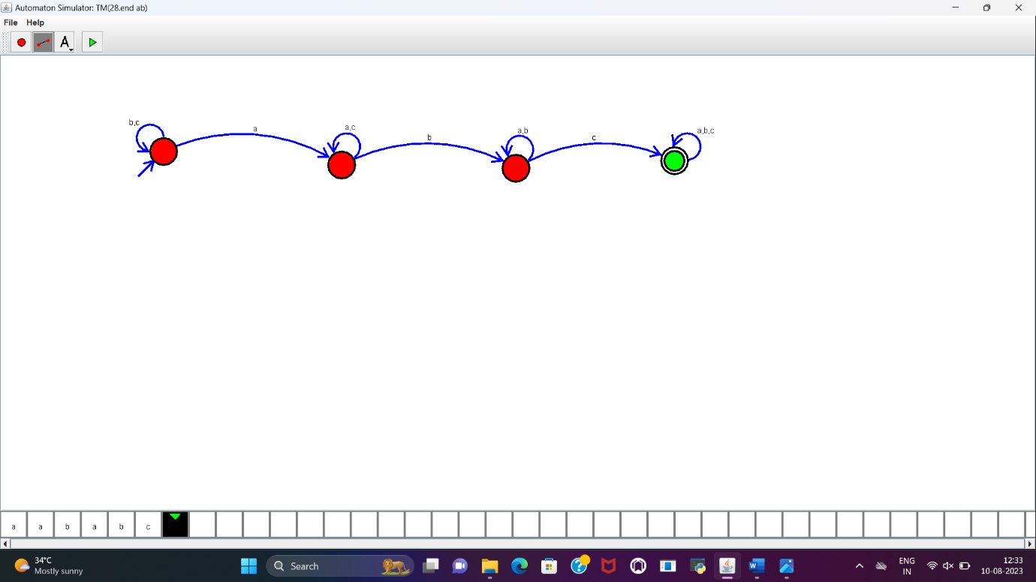

RESULT:

DFA to accept the string having “abc” as substring is designed and implemented successfully.